# Assignment-4

|  |  |
| --- | --- |
| **Date** | **19September2022** |
| **StudentName** | **Ayeshwarya.R** |
| **MaximumMarks** | **2Marks** |

1. PullanImagefromdockerhuband runitindocker playground.

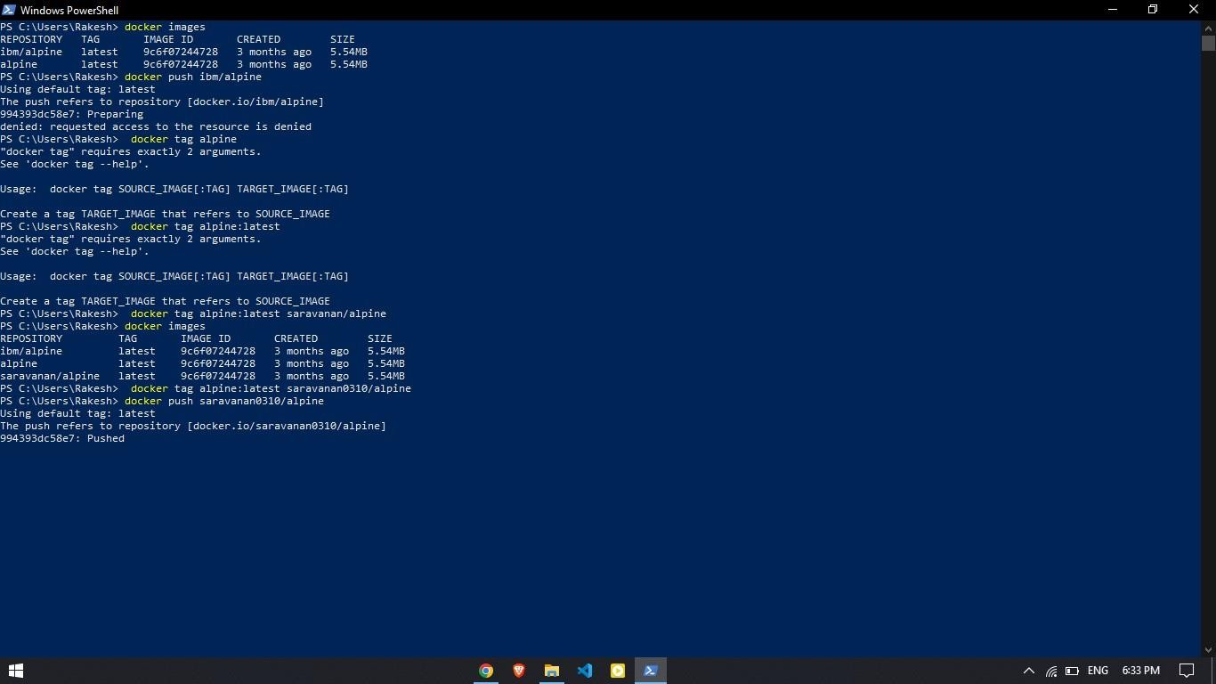

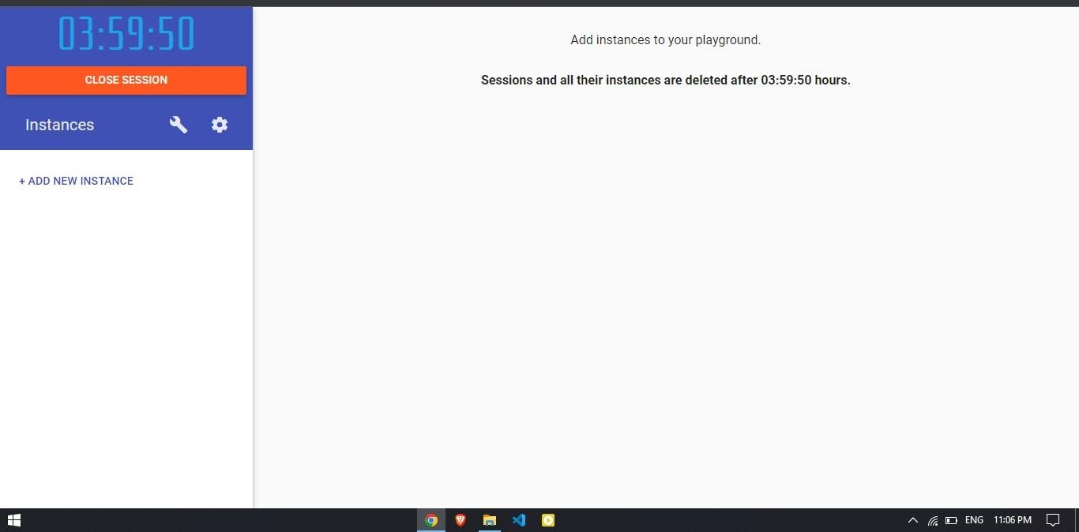

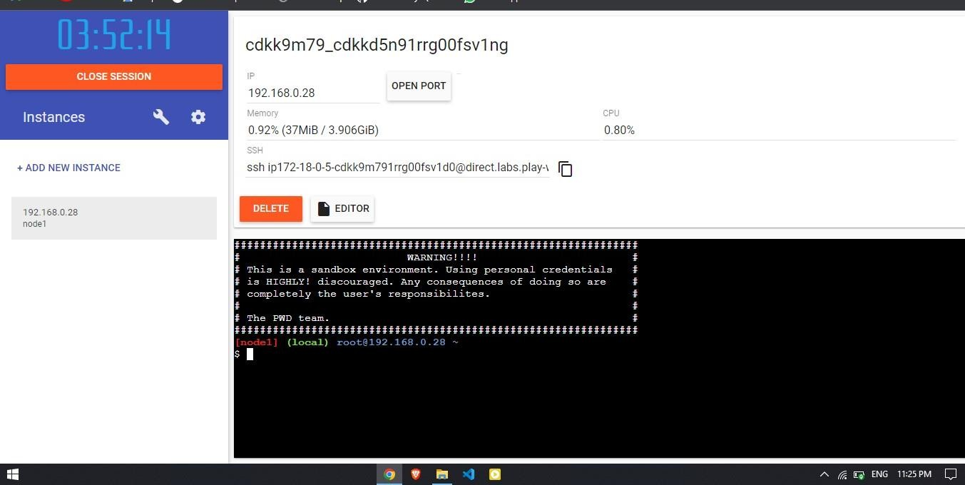

1. CreateadockerfileforthejobportalapplicationanddeployitinDockerdesktopapplication.



Dockerfile

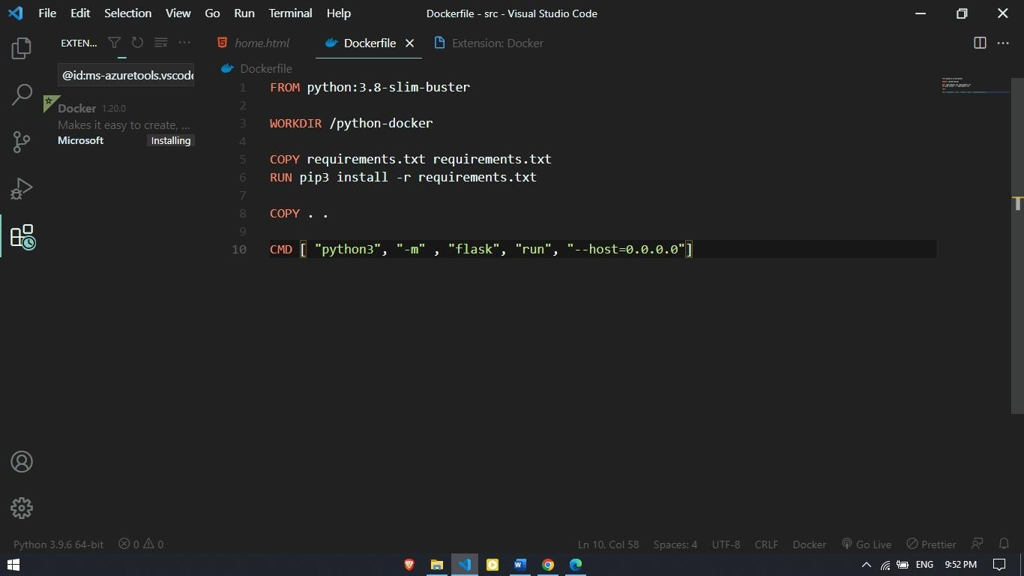

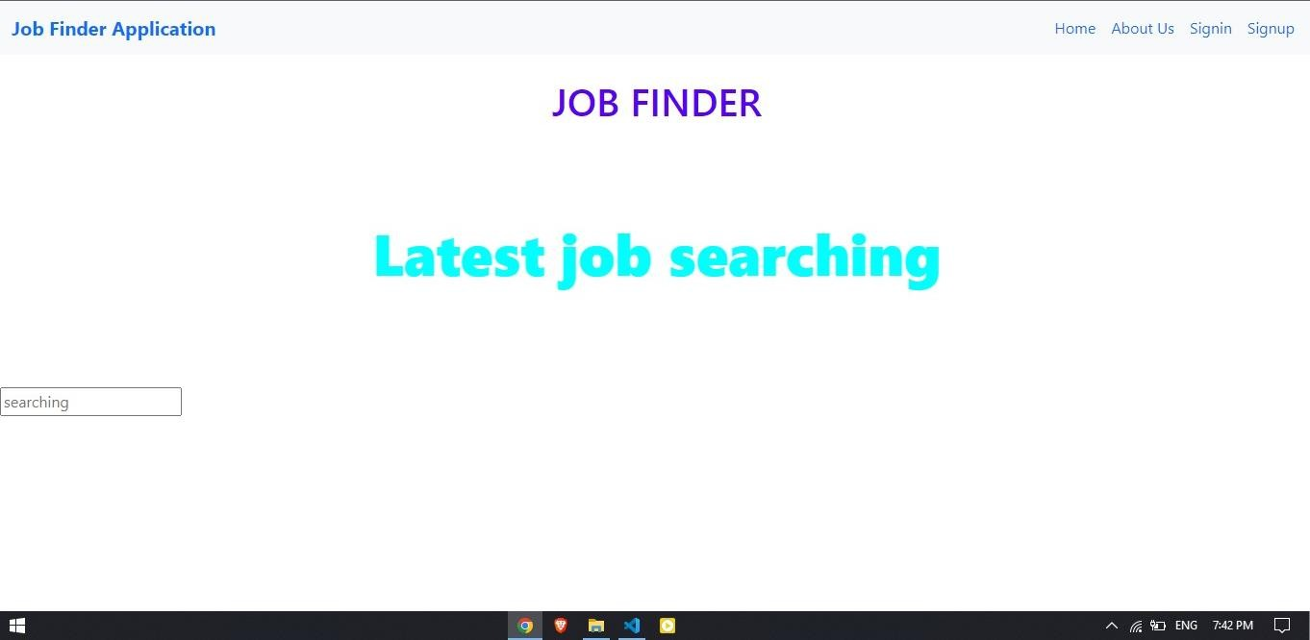

# CreateaIBMcontainerregistryanddeployhelloworldapporjobportalapp.

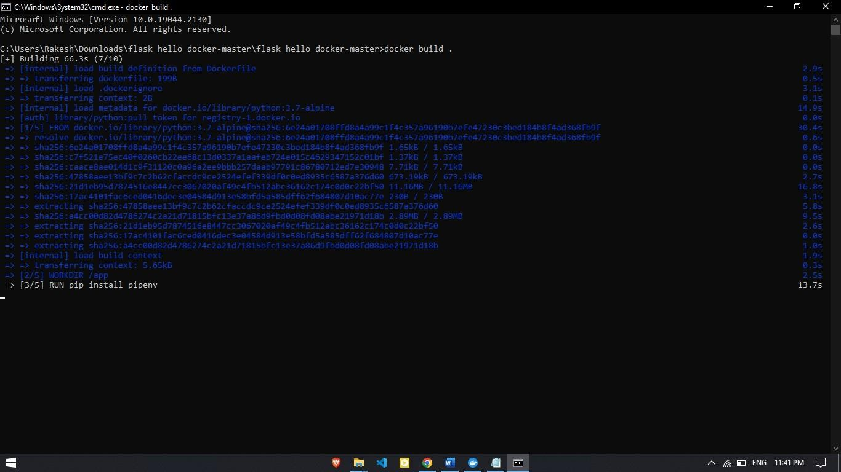

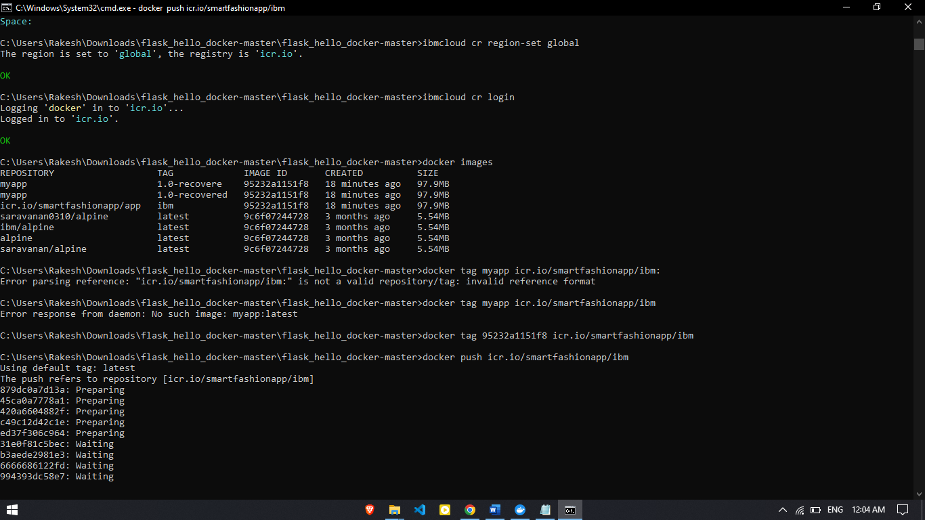

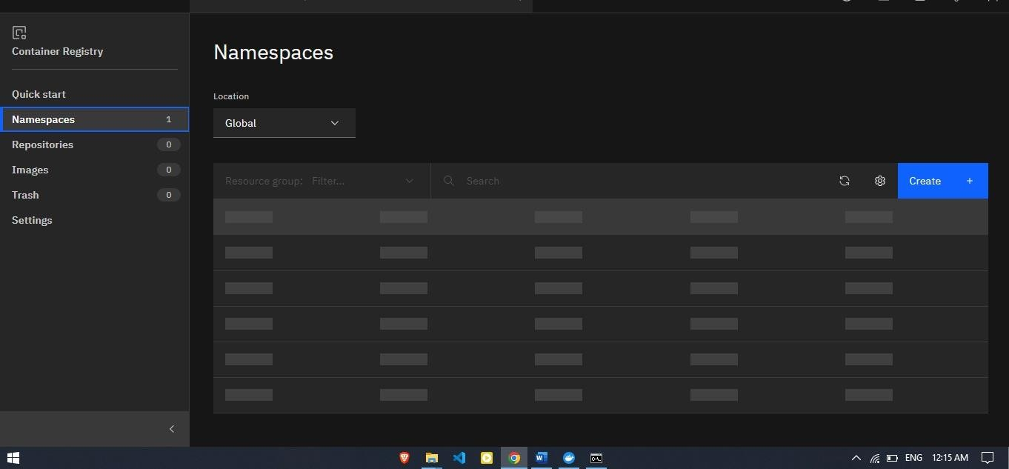

1. **CreateaKubernetesclusterinIBMcloudanddeploy helloworldimageor jobportalimageandalsoexposethesameapptoruninnodeport.**

